HTML (Hypertext Markup Language)

Basic Structure of HTML
The <!DOCTYPE> declaration for HTML5

<!DOCTYPE html>
<html>
<head>
<title>Page Title</title>
</head>
<body>
<h1>This is a Heading</h1>
<p>This is a paragraph.</p>
</body>
</html>

The <!DOCTYPE> declaration represents the document type, and helps browsers to display web pages correctly.
The <!DOCTYPE> declaration is not case sensitive.

Heading Tags
<!DOCTYPE html>
<html>
<head>
<title>Page Title</title>
</head>
<body>
<h1>Heading 1</h1>
<h2>Heading 2</h2>
<h3>Heading 3</h3>
<h4>Heading 4</h4>
<h5>Heading 5</h5>
<h6>Heading 6</h6>
</body>
</html>

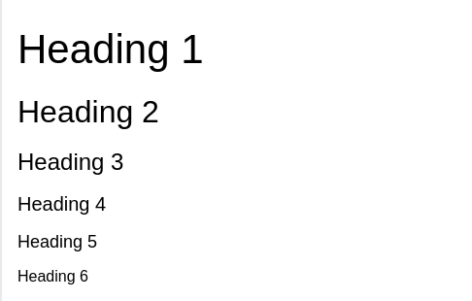

Note: Use HTML headings for headings only. Don't use headings to make text BIG or bold.

Paragraph Tag

With HTML, you cannot change the display by adding extra spaces or extra lines in your HTML code.
The browser will automatically remove any extra spaces and lines when the page is displayed:

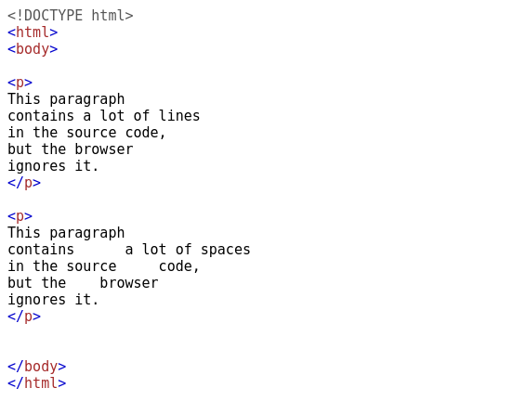

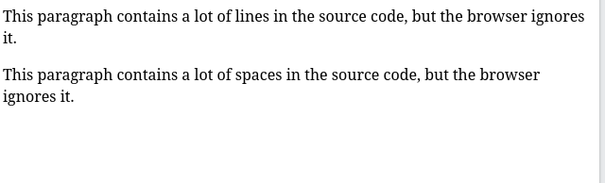

HR and BR tag
The <hr> element is used to separate content (or define a change) in an HTML page:

<!DOCTYPE html>
<html>
<body>

<h1>This is heading 1</h1>
<p>This is some text. <br> This is line break</p>
<hr>

<h2>This is heading 2</h2>
<p>This is some other text.</p>
<hr>

<h2>This is heading 2</h2>
<p>This is some other text. this is without line break</p>

</body>
</html>
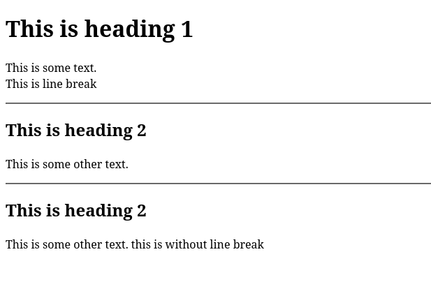

Bold, Itallic, Subscript, Superscript

<!DOCTYPE html>
<html>
<body>

<p>This text is normal.</p>

<p><b>This text is bold.</b></p>
<p><i>This text is itallic.</i></p>
<p><u>This text is underline.</u></p>
<p>Namaste<sub>This text is subscript.</sub>World</p>
<p>Namaste<sup>This text is superscript.</sup>World</p>

</body>
</html>

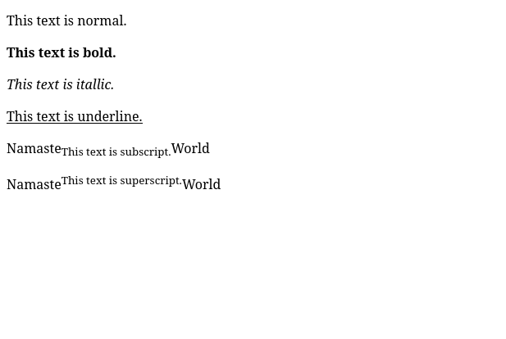

Image Tag
The HTML <img> tag is used to embed an image in a web page.
The <img> tag has two required attributes:
- src - Specifies the path to the image
- alt - Specifies an alternate text for the image
syntax: <img src="url" alt="alternatetext">

<!DOCTYPE html>
<html>
<body>
<p>This is a image<p>
<img src="img_chania.jpg" alt="Flowers in Chania" width="460" height="345">
</body>
</html>

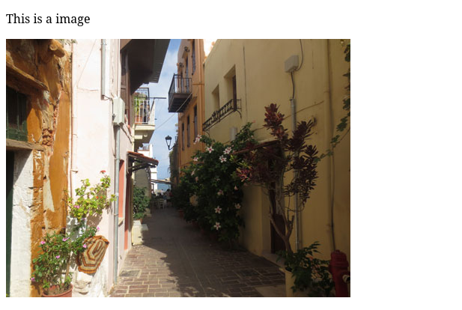

Marquee Tag
HTML <marquee> tag is used to create auto scrolling or moveable element within webpage.

<!DOCTYPE html>
<html>
<head>
<title>HTML marquee Tag</title>
</head>
<body>
<!-- Marquee Element Default Scrollong from right to left -->
<marquee>
<h2>Tutorialspoint: Simply Easy Learning</h2>
</marquee>
</body>
</html>

Example:
<!DOCTYPE html>
<html>
<head>
<title>HTML marquee Tag</title>
</head>
<body>
<h3>From right to left Scrolling</h3>
<marquee height="50" direction="left">Tutorialpoint</marquee>
<h3>From left to right Scrolling</h3>
<marquee height="100" direction="right">Tutorialpoint</marquee>
</body>
</html>

Anchor Tag
The <a> tag defines a hyperlink, which is used to link from one page to another.
The most important attribute of the <a> element is the href attribute, which indicates the link's destination.
By default, links will appear as follows in all browsers:
- An unvisited link is underlined and blue
- A visited link is underlined and purple
- An active link is underlined and red
A linked page is normally displayed in the current browser window, unless you specify another target.

Example:
<!DOCTYPE html>
<html>
<body>

<h1>The a target attribute</h1>

<a href="https://www.w3schools.com" target="_blank">Visit W3Schools.com!</a>

<p>If you set the target attribute to "_blank", the link will open in a new browser window or a new tab.</p>

</body>
</html>

